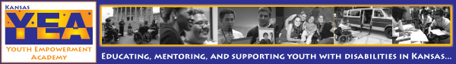
Kansas Youth Empowerment Academy Newsletter Issue #20 March 2013
Hello KYEA family and friends! Yes, it's me... your previous newsletter editor is back at it again. After a change in staff, I am back to helping out with our newsletter alongside our fantastic Washburn Bonner intern, Sydney Spyres. We are happy to bring you our March issue of the KYEA newsletter!

You will notice that this newsletter has a large focus on love and relationships for people with disabilities. We fully planned on this issue going out in February, but the snow had other ideas! You're still in the Valentine's Day spirit, right? This issue is full of KYEA updates, opportunities, an interview with one of our KSYLF alumni who is engaged, lots of helpful tips and myths related to dating, and a full list of great websites that will help you to explore relationships and sexuality. Who says that people with disabilities don't want to date, flirt, or be in relationships? This is SO not true! We want, and deserve, love just like everyone else. So, read on to see that it is possible for you too!

Enjoy!
- Carrie Greenwood, Program Coordinator

Please show your support for youth with disabilities by donating to KYEA today. You can donate directly by mail or by visiting our website. We hope you will enjoy the return of our newsletter, full of local updates, national news, and even more about the amazing things youth with disabilities are doing in Kansas.

in this issue

:: Behind Julia's Glasses

:: Meet our Administrative
Assistant and ICONs

:: State and National
Opportunities

:: Common Myths about
People with Disabilities in
Relationships and Dating

:: KYEA Updates

:: Spotlight On:
Danielle and Peter

:: Tips for Dating

:: Helpful Websites
Behind Julia’s Glasses
By Julia Thomas, Executive Director

Love is...

•Someone calling you right before a snow storm and asking if you need a ride to the grocery store in case you get snowed in.
•Someone bringing leftovers to you on Christmas because you spent Christmas alone.
•Spending time with your parents doing nothing but eating, watching tv, and talking.
•Someone folding your underwear when you are too sick to do it yourself.
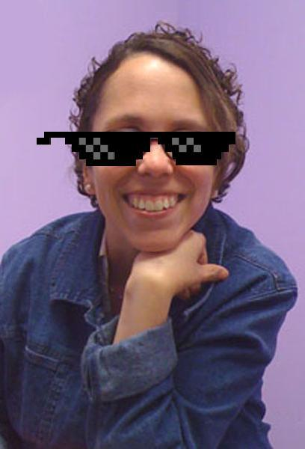
•A friend sending you an e-mail to console you while you are going through a hard time in your life.
•Your personal attendant hanging out with you, not because they are getting paid, but because they want to.
•Your hairdresser telling you your eyebrows need help and your neck needs to be shaved.
•Making the effort to value all cultures and their impact by celebrating times like Black History Month.
•Listening to someone complain about the same thing twice.
•Giving your beloved dog to a shelter because you cannot give her the care that she needs.

Behind Julia’s Glasses (cont.)

•A text from someone saying that they hope you have a good day.
•Someone sitting silent with you and holding you when you cry.
•Someone giving testimony at the Capitol to protect your right to choose.
•Someone supporting you even if they don't agree with a choice you made.
•Someone smiling at you.
•Someone making your coffee just the way you like it.
•Someone telling you that you have a spot on your shirt.
•Getting an unexpected hug.

Love is everywhere. Love is more than being in an intimate relationship with someone. Love can be expressed to everyone whether they are close to you or you just met them. Love is acceptance and valuing someone. My question to you... who do you accept and value? If you can show them that love on February 14th, then why can you not show it to them during the other 364 days of the year? I challenge you!

Meet our new Administrative Assistant!  Sarah Roth  Age: 24  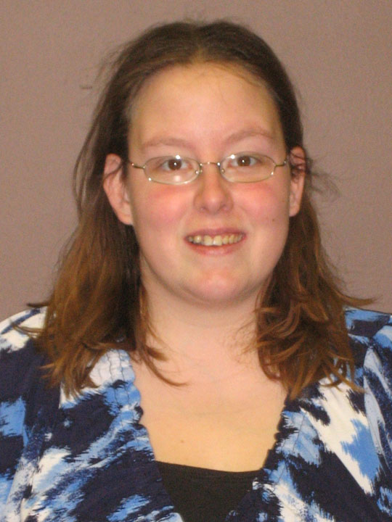  Education: Currently attending Washburn University, working on Bachelor's degree in Technology Administration with minors in Leadership and Business. Also working on entrepreneurship certificate.  Favorite thing about working at KYEA: Slowly meeting the youth and learning about the programs, as well as helping with No More Bull at Seaman High School.  Favorite hobbies: Cooking and training my dogs. |  | KYEA Updates  Sharing all things new in our KYEA world...  Seeking Items for Upcoming Garage Sale and Bake Sale Fundraiser  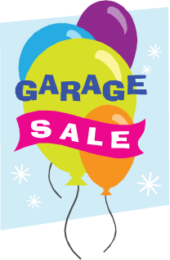  We are currently seeking donations of items for our fundraiser garage and bake sale event, which will be held on Saturday, April 13. Please drop off your donations of: toys in working condition, board/computer games, CDs, DVDs, small working kitchen appliances or other kitchen gadgets, decorative items (knick knacks, picture frames), books, small pieces of furniture, accessories (jewelry, hats, handbags, scarves, etc.), house wares (sheets, towels, etc.). No clothing or shoes please.  Donations of baked goods will be accepted on the 10th-12th of April. Please drop them by our office. We are looking for the following: home-baked pies, cakes, cupcakes, cookies, quick breads, pastries, coffee cakes, etc.  Visit www.kyea.org/garagesale13 for more information.
Meet our ICONS!
Not only do we have youth interns in our main Topeka KYEA office, but we also have ICON's in two centers for independent living as well. Learn all about them on the next page...

Allison Nichols  Age: 19  Education: Graduating from Washburn Rural High School on May 19, 2013  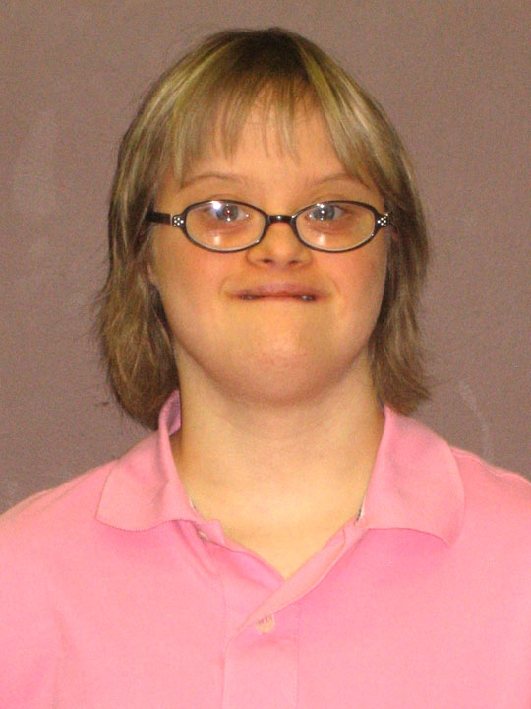  Working site: KYEA Office in Topeka  Favorite thing about being an ICON: Meeting new people  Favorite hobbies: I love to do art, cooking, Special Olympics, computer, movies, and my game boy  Allison Wilkes  Age: 24  Education: Attending Washburn University, working on Legal Office degree  Working Site: KYEA Office in Topeka  Favorite thing about being an ICON: Learning about advocacy  Favorite Hobbies: Attending and performing in choral events and music  Elizabeth (Lizzy) Hisey  Age: 19  Education: Santa Fe Trail High School  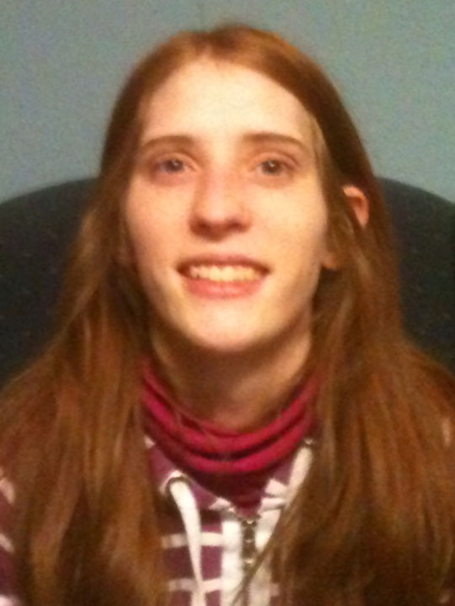  Working site: Resource Center for Independent Living in Osage City  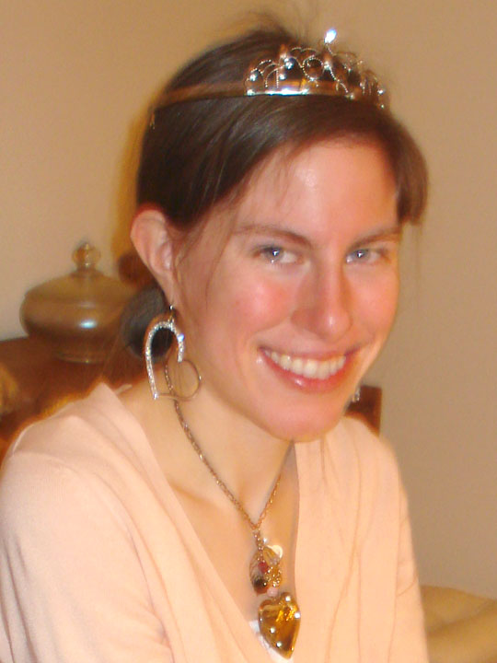  Favorite thing about being an ICON: Learning new skills that I didn't know before, like how to dress professionally, how to talk to my supervisor, how to fill out a timecard, and other professional skills.  Favorite hobbies: I like reading, playing games on the computer, photography, and drawing. |  | Calling All Topeka High School Students with Disabilities: Attend the 2013 Empower Me! Challenge!  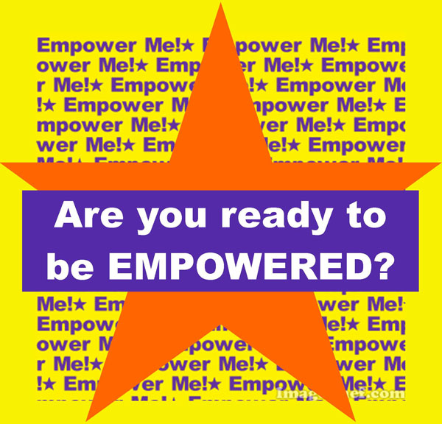  Do you know of a high school student with a disability in the Topeka area who could benefit from three weeks of empowerment? Maybe they need to learn about community resources or need a supportive environment to start thinking about issues related to their transition years and setting goals for their future. Well, KYEA has just the program for them... our Empower Me! Challenge is back for a fourth year, and we are currently recruiting for participants for our April sessions!  The 2013 Empower Me! Challenge will be a 10-session program during the school day that assists students with disabilities in exploring themselves, their abilities, and their future! The program is open to high school sophomores, juniors, and seniors with disabilities who attend school in Topeka or surrounding areas (Silver Lake or Rossville).  Visit www.kyea.org/empowerme13news for the full article  Learn more about the Empower Me! Challenge at www.kyea.org/empowerme.
Donations Needed!

KYEA needs your help! We are getting ready for KSYLF and the Empower Me! Challenge, and we are in need of supplies. We are asking for donations of backpack goodies (disposable cameras, key chains, notebooks, etc.), pop, bottled water, snacks, and gift cards. If you are able to help us or have any questions, please contact Sydney Spyres at outreachcoordinator@kyea.org. We need all the help we can get, so if you have other items not listed above, contact us, and we will let you know if we can use them!

Marshall Hoffner  Age: 19  Education: Graduated from high school  Working Site: Coalition for Independence in Kansas City  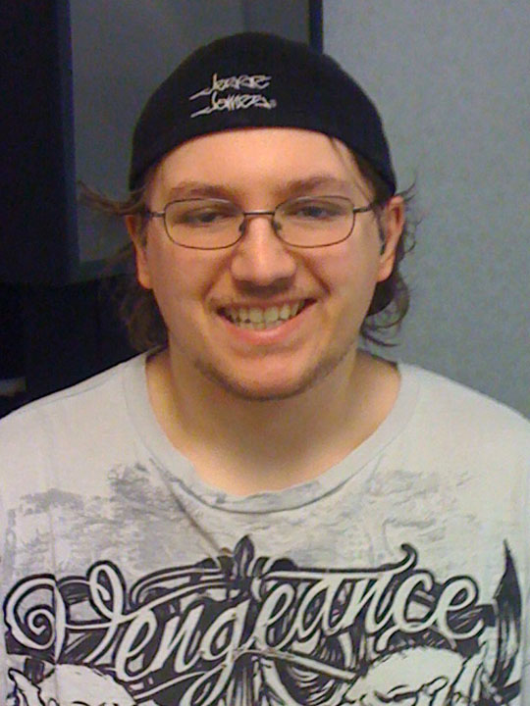  Favorite thing about being an ICON: I like the fact that you can come here and get help with housing, a work career, volunteering, or a disability that you or someone that you know has, etc.  Favorite Hobbies: Play video games, play the guitar, listen to music, watch movies, draw, play basketball, work out, and cook.  Carl VanWinkle  Age: 20  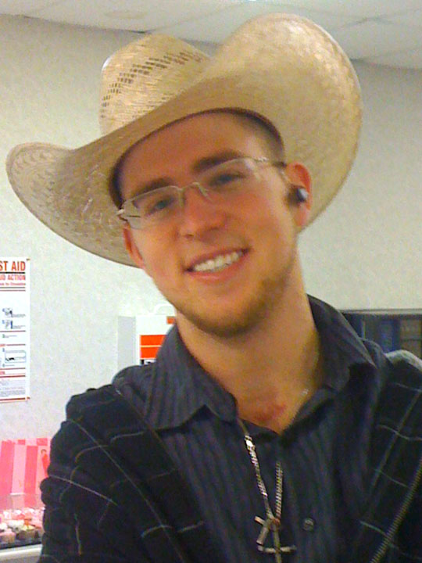  Education: Attending Johnson County Community College (JCCC) currently.  Working Site: Coalition for Independence in Kansas City  Favorite thing about being an ICON: The thing I like the most is that I have become way more appreciative of what I have.  Favorite Hobbies: Make people laugh, listen to country music, watch comedy movies, play cards, hang out with friends, watch and play baseball. |  | Spotlight On!  Danielle Hasenkamp, 23, and  Peter Willcott, 24  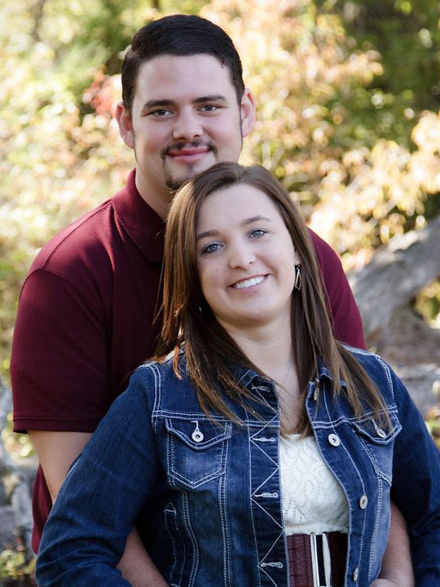  Hear firsthand one couple's journey through disability, dating, and discovery... We sat down with Danielle, KSYLF Alumna '07, and her fiancee, Peter, to get the scoop on their relationship, how disability plays into dating, and what the future holds for this awesome couple. Read on...  What is your favorite thing to do to spend time together?  DANIELLE: I love taking motorcycle rides on Peter's motorcycle. It is definitely relaxing!!  PETER: I like to relax and watch movies with Danielle.  What was one of the challenges you have faced in your relationship?  DANIELLE/PETER: For the first two years of our relationship, we have lived at least one, if not two, hours away from each other.  What is the best part of being in a relationship?  DANIELLE/PETER: The best part about being in a relationship is always knowing that I have someone by my side through the good and bad times.  Read more on the next page…
News and Events

Opportunities in Kansas

- Are you a parent of a youth with a disability? Then attend the upcoming Families Together "Together We Can Learn" Conference! Read more at http://familiestogetherinc.org/?page_id=783.

- Attend the 4th annual Autism Awareness Carnival on April 27 in Topeka! This year's event will be held at Washburn Tech. Come on out to learn about Autism resources, products, information, and experience a fun day for the whole family!

- Mental Health Advocacy Day at the Capitol is on March 14. Join fellow consumers, family members, providers and advocates to learn about current mental health policy and budget issues, as well as educate Kansas Legislators! Read more at www.nami.org.  Opportunities on a National Level  - Are you a youth leader with a disability? The HSC Foundation's ADA Program is seeking the next generation of disability advocates. Apply for the 2013 Advocates in Disability Award and get support for your very own project! Read more at www.hscfoundation.org/node/11#ada.  - SCHOLARSHIP! Through the Looking Glass- for high school seniors or college students who have parents with disabilities. Read more at www.lookingglass.org.  - Want to win a customized wheelchair accessible vehicle? Then submit your story for the National Mobility Awareness Month campaign! Read more at www.mobilityawarenessmonth.com.  - Learn everything you would ever want to know about the Americans with Disabilities Act! Attend the 2013 ADA Symposium in San Antonio. Read more at www.adasymposium.org.  - Find and rate accessible locations across the country! Visit this new website and download the mobile app- www.ableroad.com. |  | How did the topic of you having a disability first come up?  DANIELLE: To be honest, Peter saw my hearing aids the first night we met (which I didn't know about). After one month of dating, Peter asked me, "Why do you want to become a special education teacher?" From that question, I told him about my hearing impairment and how I want to make a positive impact for those who also have a disability.  Had you ever thought about dating a person with a disability?  PETER: I didn't even think about it. I personally don't think Danielle has a disability; it's who she is.  Read the full interview at www.kyea.org/daniellepeter.
People with disabilities CAN and SHOULD work! Check out this clip of real people with disabilities successfully contributing to society...
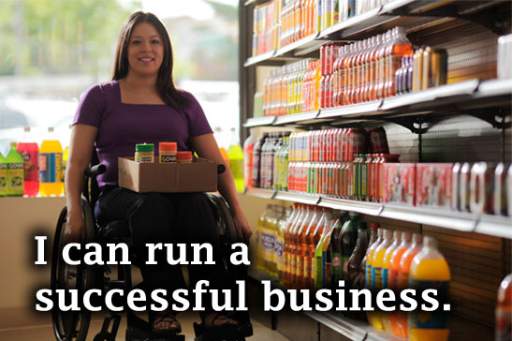
View at ww.youtube.com/watch?v=BG_W7wAe1kw
Mythbusters in Action!  Common Myths about People with Disabilities in Relationships & Dating  by Julia Thomas and Rachel Klaus  Do you ever assume that something is true, when it really is not? A couple of our staff took some time to come up with a list of myths that are completely NOT true. Read on and see if you agree...  1. People without disabilities do not find people with disabilities attractive. |  | Just a Few Tips...  A few things to keep in mind when you are a person with a disability and you are embarking on the world of dating.  by Johnna Godinez  1. Disability- it's not a dirty word. It is absolutely okay to talk about your disability when you begin dating someone. Have pride in your difference and the right person for you won't care. You wouldn't want to date someone where your difference was a big deal.

2. People with disabilities always want to date other people with disabilities because they have more in common with them.    3. If a person with a disability is in a relationship with someone who does not have a disability, the person without the disability does everything for them or becomes their default PCA.  4. People with disabilities do not want to go on dates.  5. People with disabilities are not interested in having sexual relationships.  6. People with disabilities do not have dating standards, meaning we will date whoever is interested in us because we are just so thankful that someone is interested in us.  7. People with disabilities are not interested in how they look or have the desire to look good... meaning getting their hair done, dressing nice, etc.  8. People with disabilities cannot be good parents.  9. People with disabilities have children who are disabled.  10. People with disabilities cannot get married because of being on social security.  11. People with disabilities cannot provide their family or spouse with income.  12. A person with disabilities is less able to fulfill whatever responsibilities they have in their family. For example, if the man has a disability, he cannot be a provider for the family.  13. People without disabilities cannot relate to people with disabilities.  14. People with and without disabilities cannot be friends, and the person who does not have the disability is only being a friend out of charity. |  |   2. Advice for flirting - Honey, I know I'm cute. If you agree, then come over and talk to me because chances are I can't see you because I'm legally-blind. Flirting is very visual, but I can still flirt with my voice intonation, my word choices, and a light touch to your arm. I just need you to come closer.  3. Don't judge a book by the cover. For those of us with an obvious disability (wheelchair user, etc.), we're still great dating material, but we need you to think outside the box in terms of what makes a person attractive and not be intimidated by our equipment.  4. Look in the mirror (if you're blind, then visualize the mirror while holding it) and tell yourself that you're sexy, gorgeous, hot, amazing, desireable, loving, thoughtful, that you'd make a great girlfriend/boyfriend/partner/spouse, etc. If you don't believe these things about yourself, then no one else will either.
Helpful Websites
We know that sometimes it's hard to find good websites about relationships, dating, and sexuality for people with disabilities. We have done the research for you and compiled a list of some of the most helpful sites.

compiled by Allison Wilkes and Carrie Greenwood

Disaboom: Dating and Relationships
www.disaboom.com/dating-and-relationships
Contains links to lots of great articles on relationships, marriage, and sexuality for people with disabilities.

This Is How We Do It: Disability, Dating, and Sex
www.nyln.org/wp-content/uploads/2010/10/NYLN-Dating-and-Sexuality-Resource.pdf
Learn all of the basics of relationships, dating, and sexuality as a person with a disability. This fact sheet, created by the National Youth Leadership Network, is youth friendly and easy to understand.

Helpful Websites (cont.)

Sexuality and People with Intellectual, Developmental and Other Disabilities
http://ici.umn.edu/products/impact/232/
A special issue of the Impact magazine. Has some articles geared toward parents, but also has great articles on real people with disabilities who are in fulfilling relationships.

KASA: Dating and Relationships Resources
http://fvkasa.org/resources/dating

A great list of various articles and other websites focused on dating and relationships for people with disabilities.

Disability Dating Tips
www.disabled-world.com/communication/disabled-dating/advice/
This website gives advice for first dates for people with or without disabilities.

Dating with a Disability
http://disability.about.com/od/DisabilitiesAndRelationships/a/DatingWithADisability
Explains the emotional and cultural aspects of interacting with people with disabilities. It emphasizes the point that people with disabilities want to be treated like anyone else, especially on dates.

Sex, Etc.
http://sexetc.org
Great website for youth, by youth. It focuses on making sure youth can find all the information they are looking for about good, safe sex, bodies, relationships and more.

Dating4Disabled
www.dating4disabled.com
Focuses on helping people with disabilities develop relationships with other people with disabilities. This site checks the authenticity of the profiles of the people that sign up.

Scarleteen
www.scarleteen.com
A very youth-friendly site that provides inclusive, comprehensive sexuality information for teens.
Thanks for reading our newsletter this month! Don't forget to donate by going to our website at www.kyea.org and check us out on Facebook (www.facebook.com/kansasyea) and Twitter (www.twitter.com/kansasyea)!

Let us know what you think about our newsletter! If there is anything that we can do to make our newsletter more accessible to you, please call us at 785-215-6655 so we can make the change for next time.

Sincerely,
Carrie Greenwood
Kansas Youth Empowerment Academy

